Fractions Unit Test - Set 1
Q1. Which of the following fractions is equal to 1/2?
(a) 2/3 (b) 3/6 (c) 4/5 (d) 5/8
Q2. The numerator of 7/9 is:
(a) 7 (b) 9 (c) 16 (d) 2
Q3. Which of the following fractions is equivalent to 4/6?
(a) 2/3 (b) 3/2 (c) 6/4 (d) 5/6
Q4. If a pizza is cut into 12 equal slices and 3 slices are eaten, what fraction is left?
(a) 3/12 (b) 9/12 (c) 12/3 (d) 6/12
Q5. 2/3 of 9 is equal to:
(a) 2 (b) 3 (c) 4 (d) 6
Q6. Write the fraction whose:
(i) Numerator is 7 and denominator is 15. (ii) Numerator is 22 and denominator is 35.
Q7. Find: (i) 5/6 of 18
(ii) 1/8 of 16
Q8. Write the fraction representing the shaded portion: (i) ___ (ii) ___ (iii) ___
Q9. Fill in the missing numerators:
(i) ?/21 = 5/7 (ii) ?/10 = 1/2 (iii) ?/15 = 1/3
Q10. Find an equivalent fraction of 3/4 with: (i) Numerator 15 (ii) Denominator 48 (iii) Denominator 24
Q11. Encircle the fraction which is in lowest terms: (i) 12/18, 5/7, 9/15 (ii) 4/10, 11/13, 8/12
Q12. Write next three equivalent fractions of: (i) 1/4 (ii) 2/3 (iii) 5/9 (iv) 4/7
Q13. Which is smaller: (i) 3/16, 21/32 (ii) 18/25, 2/5 (iii) 8/21, 7/20 (iv) 3/16, 21/32 (v) 18/25, 2/5

Questions Set 2
Q1: Find the sum. (4/14) + (4/14) = ____
Q2: Find the sum. (7/11) + (5/11) = ____
Q3: Find the sum. (8/10) + (5/10) = ____
Q4: Find the sum. (2/9) + (3/9) = ____
Q5: Find the sum. (24/25) + (20/25) = ____
Q6: Find the sum. (5/8) + (7/8) = ____
Q7: Find the sum. (1/2) + (1/2) = ____
Q8: Find the sum. (11/13) + (12/13) = ____
Q9: Find the sum. (1/3) + (1/3) = ____
Q10: Find the sum. (6/50) + (15/50) = ____
Q11: See the pie charts and write the equivalent fractions in the box.
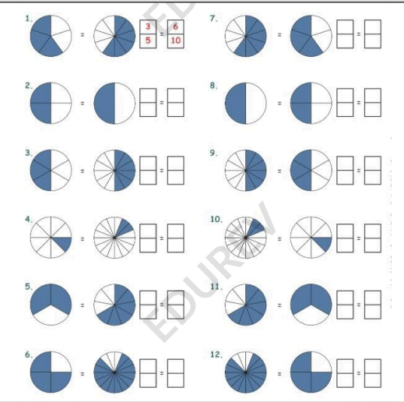

Answers Set 1
Q1. (b) 3/6
Q2. (a) 7
Q3. (a) 2/3
Q4. (b) 9/12
Q5. (d) 6
Q6. (i) 7/15 (ii) 22/35
Q7. (i) 15 (ii) 2
Q8. (i) 1/3 (ii) 1/4 (iii) 3/4
Q9. (i) 15 (ii) 5 (iii) 5
Q10. (i) 15/20 (ii) 36/48 (iii) 18/24
Q11. (i) 5/7 (ii) 11/13
Q12. (i) 1/4 → 2/8, 4/16, 8/32 (ii) 2/3 → 4/6, 8/12, 16/24 (iii) 5/9 → 10/18, 20/36, 40/72 (iv) 4/7 → 8/14, 16/28, 32/56
Q13. (i) 3/16 (ii) 2/5 (iii) 7/20 (iv) 3/16 (v) 2/5

Answers Set 2
Q1: (4/14) + (4/14) = 8/14 = 4/7
Q2: (7/11) + (5/11) = 12/11
Q3: (8/10) + (5/10) = 13/10
Q4: (2/9) + (3/9) = 5/9
Q5: (24/25) + (20/25) = 44/25
Q6: (5/8) + (7/8) = 12/8 = 3/2
Q7: (1/2) + (1/2) = 1
Q8: (11/13) + (12/13) = 23/13
Q9: (1/3) + (1/3) = 2/3
Q10: (6/50) + (15/50) = 21/50

Q11: Equivalent fractions based on pie charts (not fully visible in uploaded PDF).
